Sri Lanka Institute of Information

Technology



Lab Submission

Lab sheet No 05

**IT24100884**

**Amarathunga A.D.M.D.D**

**IT2120 - Probability and Statistics**

B.Sc. (Hons) in Information Technology

**Exercise**

**1)**

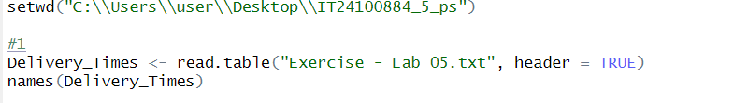

**2)**

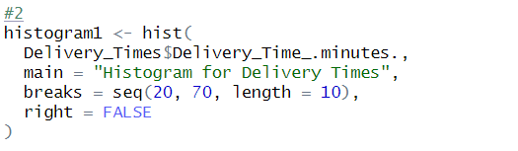

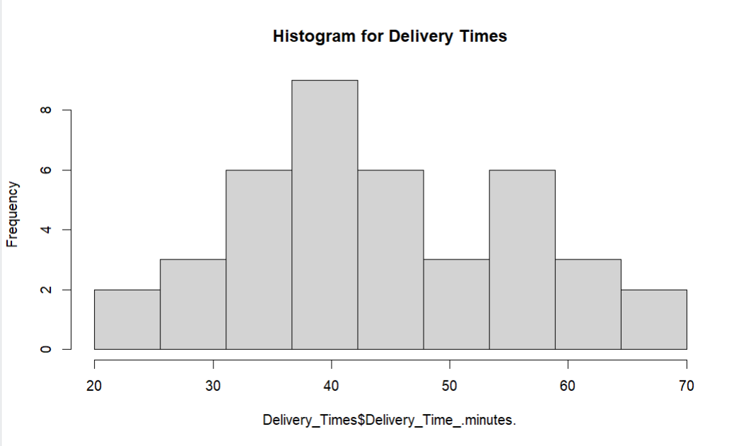

**3) The delivery times are roughly symmetric and bell-shaped.**

**4)**

